# 

# Student Instructions for Accessing the AVID Application

1. ***Log into the DESKTOP version Student/ Family Access***. (not available in Mobile APP)
2. Locate the link on the left: ***Online Forms***.
3. Select the link to Fill out the ***Form: OPTIONAL AVID Application***.
4. Review the information and then ***select: Step 1***.
5. Scroll down the document and ***mark the step completed*** to move to step 2.
6. ***Submit the form*** in step 2.

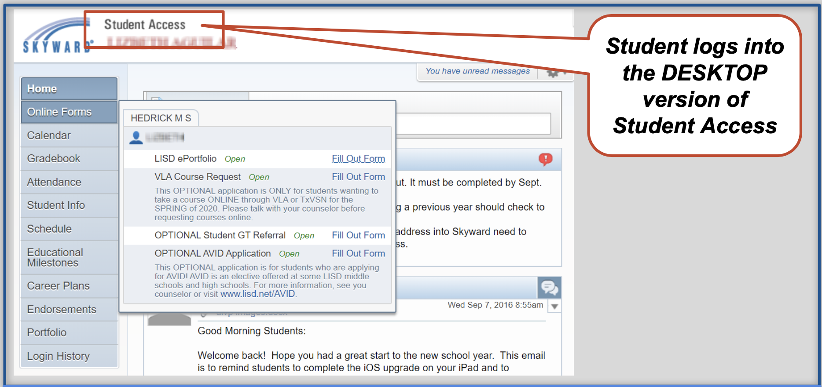

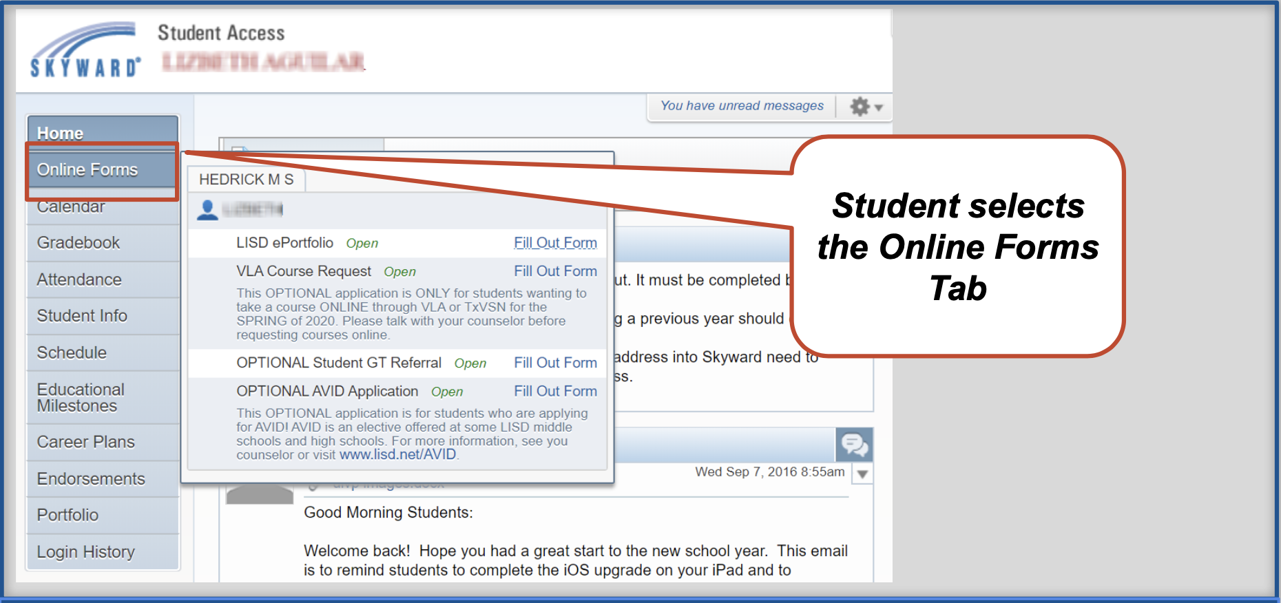

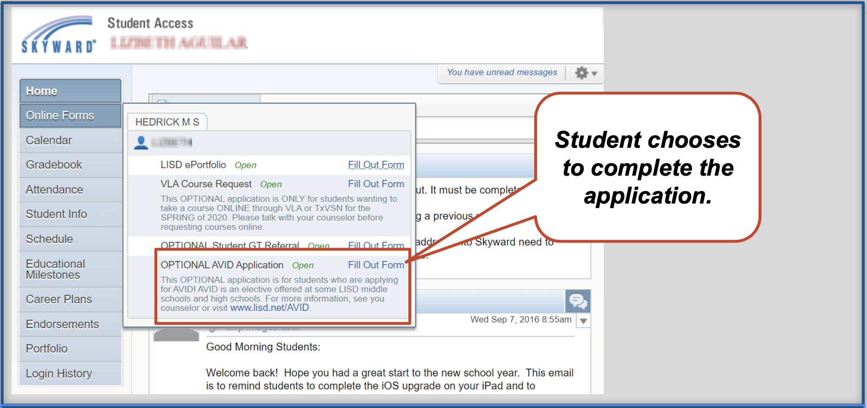

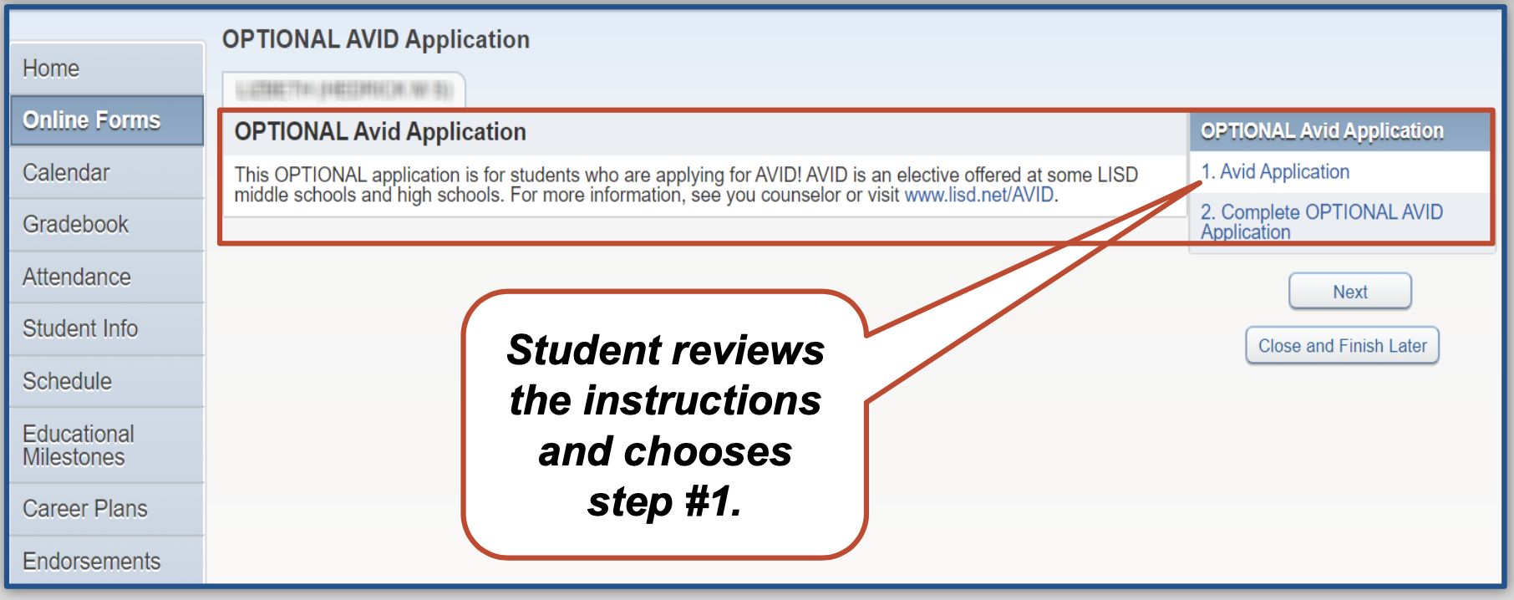

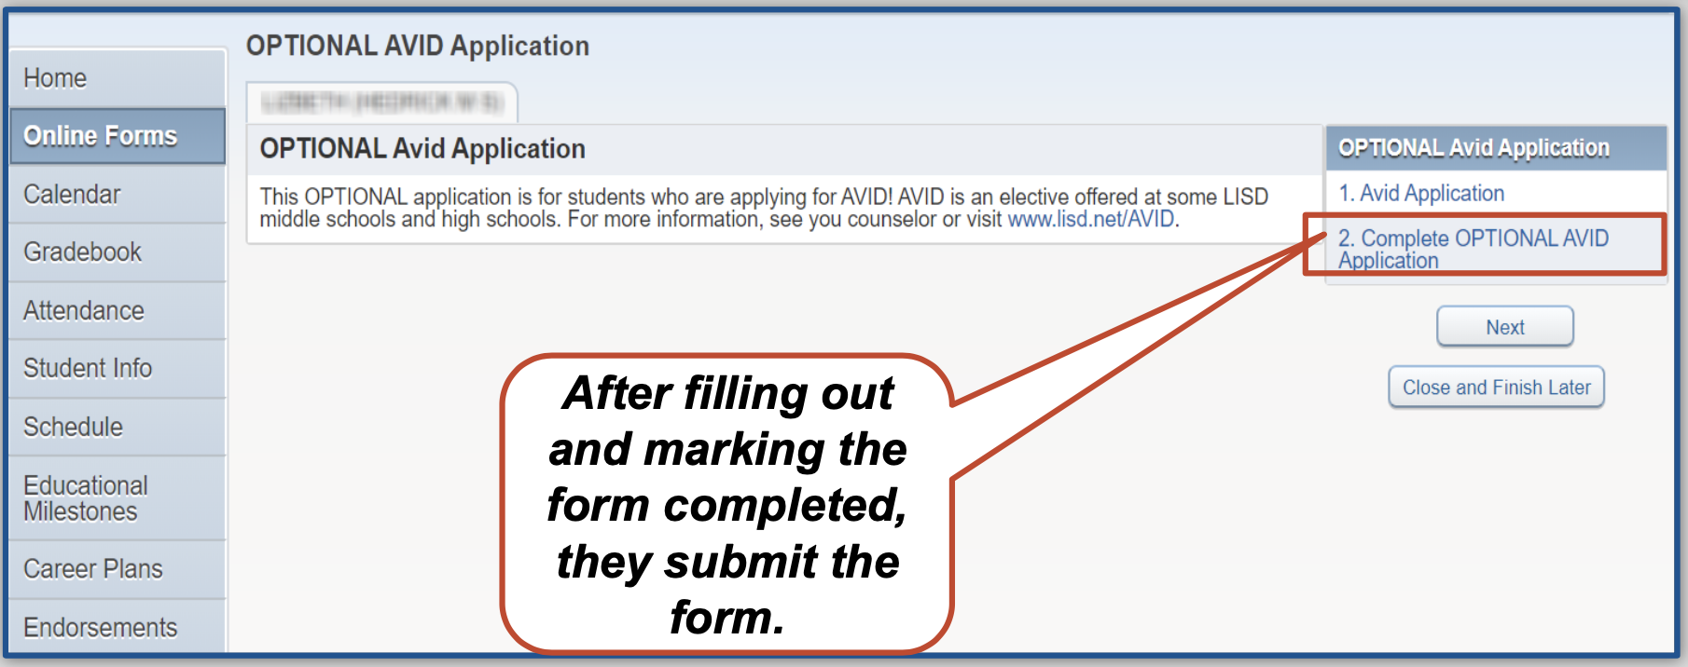

***To learn more about AVID – visit*** [***www.AVID.org***](http://www.AVID.org)

***Or contact Wendy Curran Meyer at*** [***curranmeyerw@lisd.net***](mailto:curranmeyerw@lisd.net)